**Exercise 8: Implementing the Strategy Pattern**

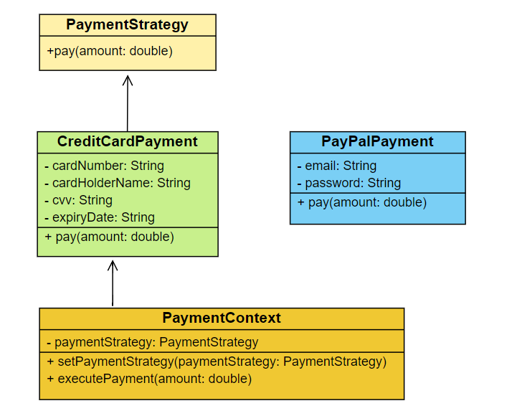In the given scenario, a payment system is developed using the Strategy Pattern, allowing dynamic selection of different payment methods at runtime. The *PaymentStrategy* interface defines a method *pay()*, implemented by *CreditCardPayment* and *PayPalPayment* classes for specific payment types. The *PaymentContext* class holds a reference to a *PaymentStrategy*, enabling the strategy to be set and executed at runtime. The *StrategyPatternExample* test class demonstrates selecting and using different payment strategies. This approach provides flexibility and extensibility for adding new payment methods without altering the existing code structure**.**

**Class Description :**

* **PaymentStrategy:** This interface defines a strategy for payment with a single method *pay().* Concrete implementations will define how to perform the payment.
* **CreditCardPayment:** Implements the PaymentStrategy interface. It simulates a credit card payment by holding card details and printing a message when the *pay()* method is called.
* **PayPalPayment:** Implements the PaymentStrategy interface. It simulates a PayPal payment by holding PayPal account details and printing a message when the *pay()* method is called.
* **PaymentContext:** This class holds a reference to a PaymentStrategy. It allows setting the payment strategy at runtime and executing the payment by calling the *pay()* method of the current strategy.
* **StrategyPatternExample:** This is the test class with the main method. It demonstrates how to use the PaymentContext to select and use different payment strategies at runtime.

Here is the github repo link - [link](https://github.com/Hyperstrom/Aniket-Pal_5017587/tree/main/WEEK-1/2.Design%20Patterns%20and%20Principles/Excercise-8)

Here is the ouput of the code –

